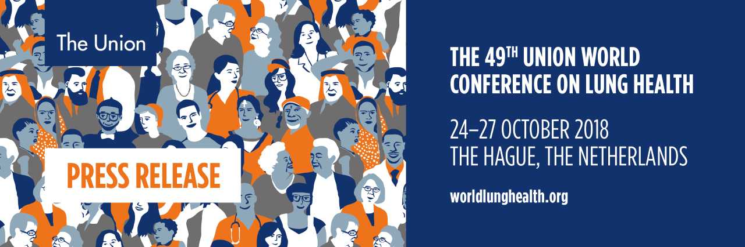

Press Release for Immediate Release
TUBERCULOSIS AT THE CROSSROADS: HUMAN RIGHTS AND TB SCIENCE UNDER THE SPOTLIGHT AT THE 49TH UNION WORLD CONFERENCE ON LUNG HEALTH TO BE HELD IN THE HAGUE
Thursday, 18 October 2018, (The Hague, The Netherlands) -- Last year 10 million people fell ill with tuberculosis (TB) and 1.6 million died from the disease. Tuberculosis, a preventable and curable disease, now kills more people than HIV/AIDS and is the world´s largest infectious disease killer.
The scale of this global health emergency was recently acknowledged by the United Nations which held the inaugural High-Level Meeting on TB in New York last month culminating in a Political Declaration signed by world leaders committed to ending TB by 2030.
The UN Meeting highlighted the need to consider the TB crisis as a human rights issue at the same time that it focused on the need to drastically step up investment in research and development that could deliver new diagnostic tools, new drugs and a vaccine.
Against this backdrop the latest research into prevention, cure and vaccines will be explored at the 49th Union World Conference on Lung Health (Union World Conference). More than 3500 researchers, policy makers and advocates will gather at the World Forum in The Hague, The Netherlands 24-27 October.
The conference theme is Declaring Our Rights: Social and Political Solutions highlighting the essential need for a human rights approach and greater political commitment to eradicate TB and reduce the global threats of tobacco use, air pollution and other lung diseases.
Conference Programme
Across a four-day conference programme, the Union World Conference looks not only at scientific advances, but also at the obstacles to developing safe and user-friendly forms of TB prevention and the delivery of drugs to treat the disease and at strategies to address the barriers to making effective prevention and treatment available to all. The global conference features more than 1,000 scientific presentations, including oral and poster abstract sessions, plenaries by the world’s leading lung health researchers, symposia, workshops, satellites and a Community Space, De Ontmoeting, open to the general public.
For the first time in the Conference´s history a pre-conference event TB Science2018 will be held, focusing on basic science.
Childhood TB
An estimated one million children become ill with TB and 239,000 children die every year (including children with HIV associated TB). Child TB is a human rights issue.
The Union World Conference will shine a light on child TB at two key events:
- Silent Epidemic: A photographic exhibition of childhood TB and The Union’s work in Africa to find better ways to address child TB, The Hague City Hall Atrium (Monday 22 October – Saturday 27 October)
- Book Launch: Childhood TB & Stigma: Conversations of Resilience in the War Against TB (to be included in the Official Opening Press Conference)
VIPS
Her Imperial Highness The Princess Akishino of Japan, and Her Royal Highness Princess Margriet of The Netherlands will both attend the Union World Conference.
The royal guests will first attend The Union President’s Centennial Dinner to be held this year in the Ridderzaal, Hall of Knights, in The Hague.
In this same place, 86 years ago, Princess Margriet’s great-grandmother, Her Majesty Emma, mother of Queen Wilhelmina, and His Royal Highness Prince Hendrick of The Netherlands attended the opening of the 8th Union World Conference.
On Wednesday 24 October the royal guests will attend the opening ceremony of the 49th Union World Conference, at which Princess Margriet will speak as patron of the conference’s local hosts, KNCV Tuberculosis Foundation.
HIH Princess Akishino will attend numerous scientific sessions throughout the conference. As Patron of the Japan Anti-Tuberculosis Association (JATA), she will present the prestigious Princess Chichibu Memorial TB Global Award. The award recognises outstanding contributions to global TB control and is presented annually by JATA, a heritage member of The Union.
Press Programme and Registration
The Union World Conference press conference programme (full programme here) includes daily overviews of some of the most compelling research being presented at the meeting, including:
- Monday 22 Oct: Towards a TB Vaccine (12:00 –12:45 CEST)
- Wednesday 24 Oct: Official Opening Press Conference (16:00 – 16:45 CEST)
- Thursday 25 Oct: Scientific Breakthroughs in TB Prevention (10:30 – 11:15 CEST)
- Thursday 25 Oct: Curing MDR-TB- Emerging Success Stories (12:30 – 13:15 CEST)
For journalists who cannot attend in person, all press conferences will be live-streamed on You Tube and available for playback on The Union´s Facebook page. The conference offers complimentary registration, a fully staffed media centre and extensive professional support.
Details on media registration for the 49th Union World Conference on Lung Health are available here
ENDS
Further Information:
Michael Kessler Media Relations Consultant
Mobile: +34 655 792 699 Email: michael.kessler@intoon-media.com
OR contact: press@theunion.org
About the 49th Union World Conference on Lung Health
The Union World Conference on Lung Health, convened by the International Union Against Tuberculosis and Lung Diseases (The Union) is the world’s largest gathering of clinicians and public health workers, health programme managers, policymakers, researchers and advocates working to end the suffering caused by lung disease, with a focus specifically on the challenges faced by low-and lower-middle income populations. Of the 10 million people who die each year from lung diseases, some 80 percent live in these resource-limited settings.
Organising international conferences on TB and related subjects has been a core activity of The Union since its founding in 1920.
About The International Union Against Tuberculosis and Lung Disease (The Union)
The Union was founded in 1920 and is the world’s first global health organisation. We are a global leader in ending TB, we fight the tobacco industry, and we solve key problems in treating major diseases. We use science to design the best treatments and policies for the most pressing public health challenges affecting people living in poverty around the world. The Unions members, staff and consultants operate in more than 150 countries and embody our core values of accountability, independence, quality and solidarity.

